1. First Install Chocolatey in Your Pc in Windows PowerShell-Run as Administrator

Command:

Set-ExecutionPolicy Bypass -Scope Process -Force; [System.Net.ServicePointManager]::SecurityProtocol = [System.Net.ServicePointManager]::SecurityProtocol -bor 3072; iex ((New-Object System.Net.WebClient).DownloadString('https://community.chocolatey.org/install.ps1'))

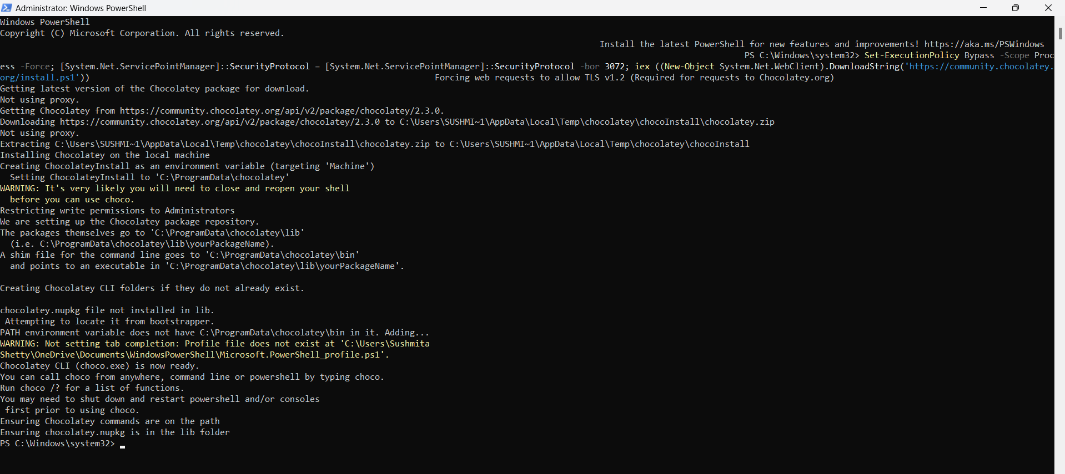

install kubectl:  
Command: choco install kubernetes-cli

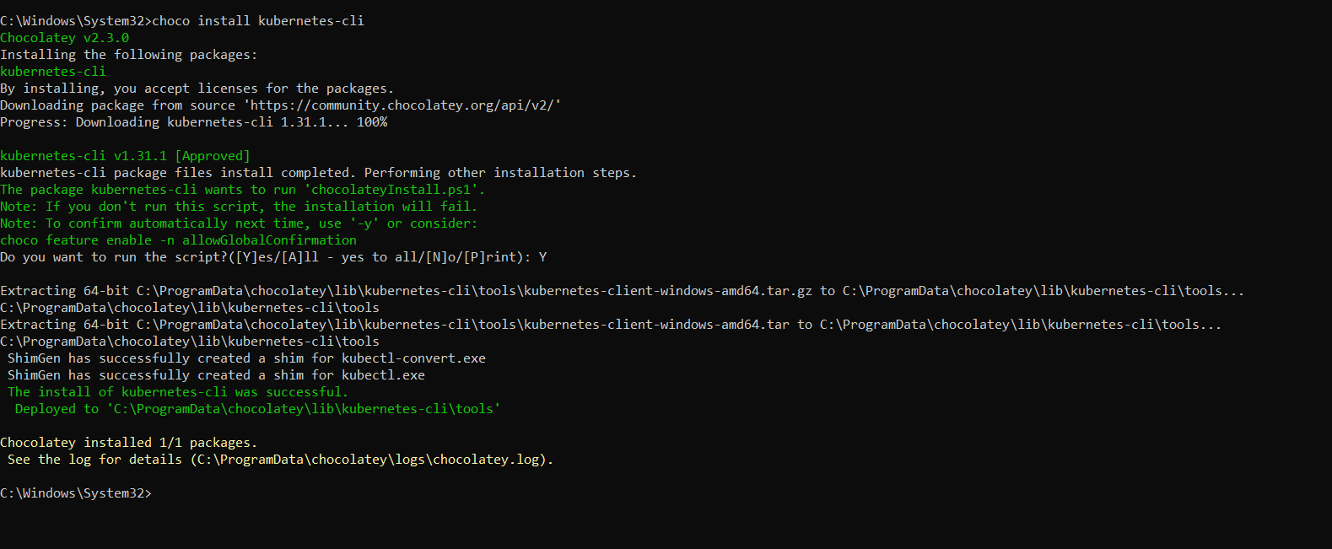

Check the version to confirm the installation:

Command: kubectl version –client

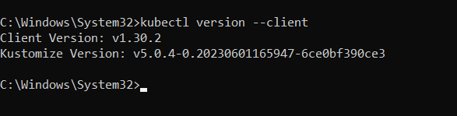

Execute this command: cd %USERPROFILE% and then run mkdir .kube

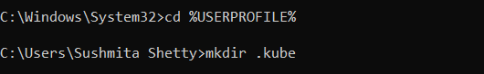

Now go to c drive🡪user🡪sushmita Shetty🡪 .kube folder. Inside that .kube folder create a config.txt file

Then download/install minikube

Command: choco install minikube

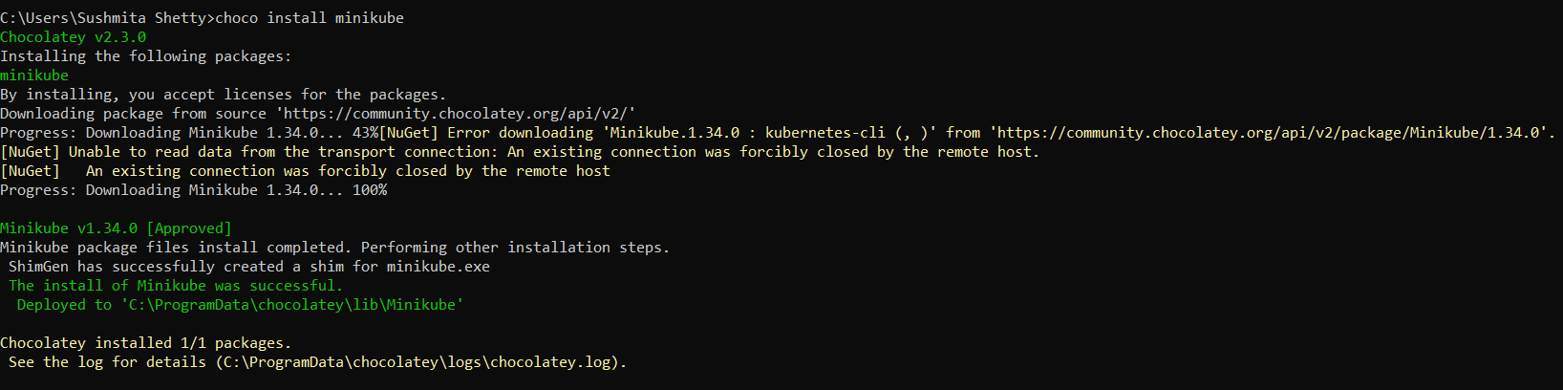

Now make a Kubernetes cluster using command: minikube start --driver=docker (ensure system has docker else install docker desktop and open)

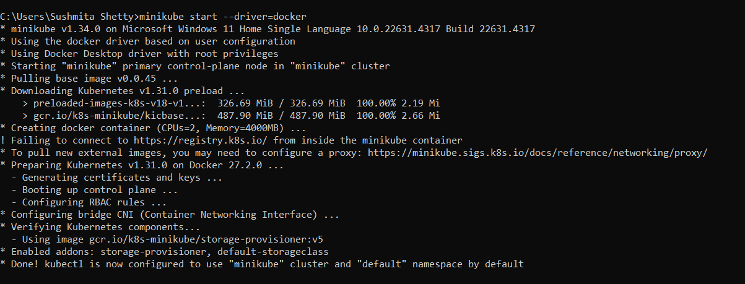

Now run docker ps to check if the container is up or not



Now run minikube status to check if the control plane is done

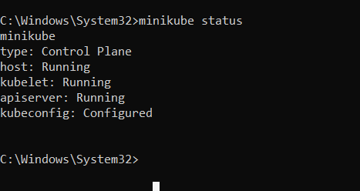

Run a pre-existing application (example nginx) on Kubernetes

Go to Docker hub-search nginx

command: kubectl create deployment my-nginx --image=nginx:latest

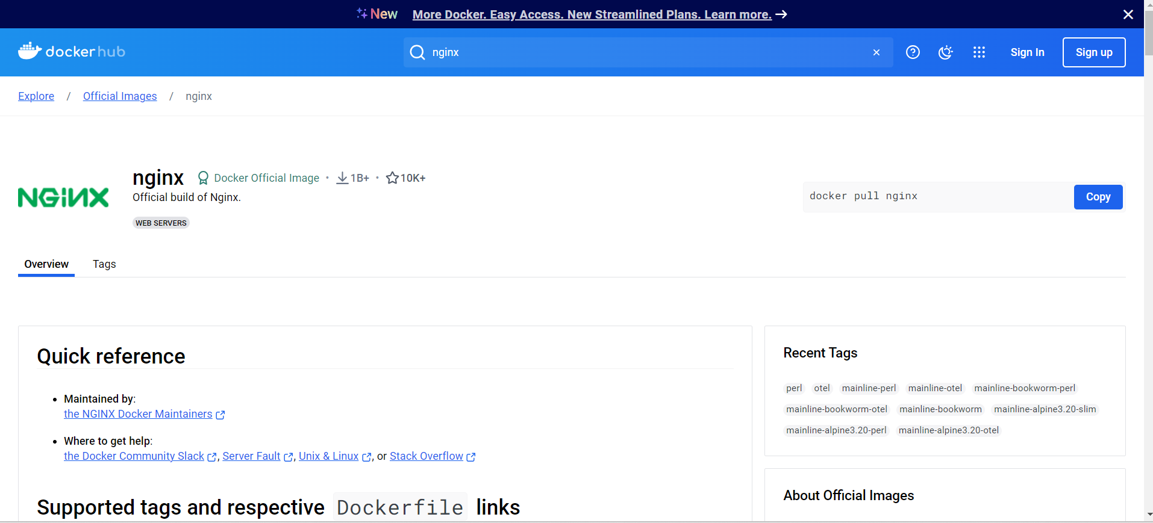

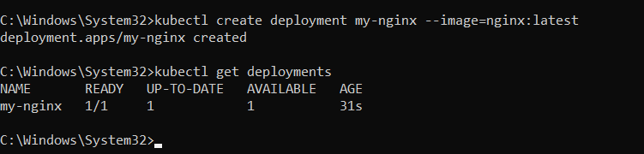

kubectl get deployments 🡪check is the my-ngnix is created

then check id the pods are created using command: kubectl get pods

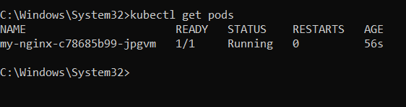

Expose the pod to minikube:

Command: kubectl expose deployment my-nginx --port=80 --type=LoadBalancer

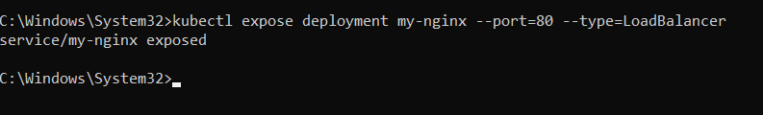

Check if your service is exposed or not

Command: kubectl get services

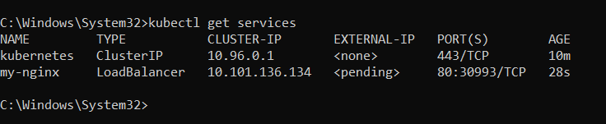  
Link your service with minikube

Command: minikube service my-nginx

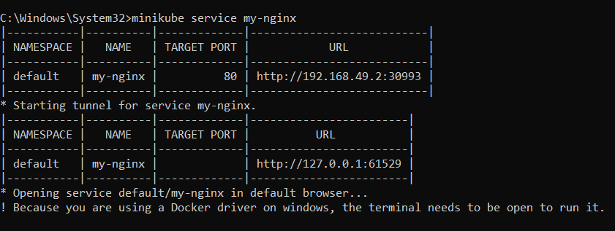

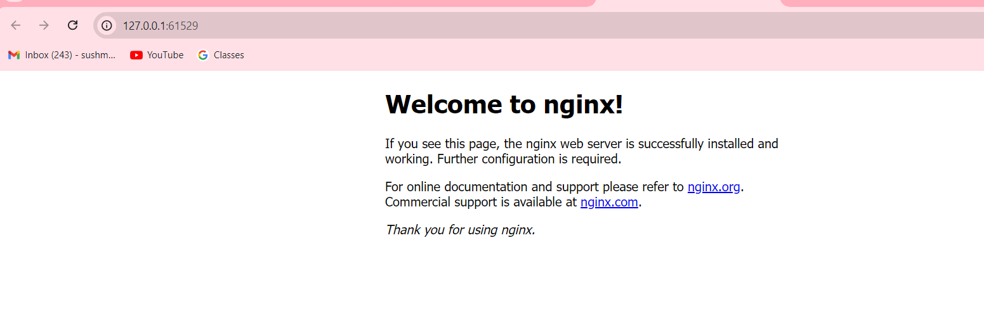

Custom application 🡪 need to be done

**SCALING ON KUBERNETES**

Scaling Up:

Command: kubectl scale deployment my-test-app --replicas=3

Then verify it if it has actually created a replica using kubectl get pods

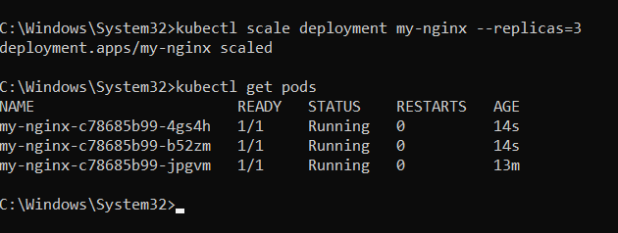

Scaling down: Command: kubectl scale deployment my-test-app --replicas=3

Again you can verify